Product Specifications

Table of Contents

Table of Contents 1
Modification History 2
Major Milestones 3
Abstract 4
Document References 5
Glossary 6
Class Diagram 7
Use Case Sequence Diagram 8
Use case 1(Register New Account) 8
Use case 2(Log in) 9
Use case 3(Play as Guest) 10
Use case 4(Reset Password) 11
Use case 5(Display Player Statistics) 12
Use case 6(Player vs. Player) 13
Use case 7(Player vs. AI) 13
Use case 8(Difficulty Level) 15
Use case 9(Select tile) 15
Use case 10(Select First Player) 16
Use case 11(Exit) 17
Exception Sequence Diagrams 18
Use case 12(Taken Username) 19
Use case 13(Incorrect Log in information) 20
Use case 14(Forgotten Username) 21
Use case 15 (Incorrect Answer to Security Question) 22
Use case 16 (Statistics for New User) 23
Use case 17 (Guest vs Guest) 24
Use case 18 (Guest vs AI) 25
Use case 19 (Player vs Guest) 26
User Interface 28
Pseudo Codes 28
Pseudo Code for ResetPassword.cpp 28
Pseudo Code for selectgamemode.cpp 30
Pseudo Code for gamemode.cpp 30
Pseudo Code for aiclass.cpp 32
Pseudo Code for gameboard.cpp 46
Pseudo Code for gameboard.cpp 50
Pseudo Code for difficultylevel.cpp 52
Pseudo Code for registrationScene.cpp 55
Pseudo Code for playergameoption.cpp 56
Pseudo Code for maintictactoe.cpp 58
Pseudo Code for Main.cpp 59
Pseudo Code for LoginScene.cpp 59
Pseudo Code for User.cpp 61

Modification History

Item | Date | Changes | Comments
1. | 2/26/2016 | - Use Case Diagram modified to accommodate guest user specifications and history record.
2. | 2/26/2016 | - Edited for consistency and clarity
3. | 4/1/2016 | - Modified use case scenarios and added all exception scenarios.  - Created all state diagrams for entity classes and UI
3. | 4/1/2016 | - Modified the documentation for testing and improving plans on development. These test faces included non-functional and functional tests
4. | 4/13/2016 | - Added missing sequence diagrams into the Pseudo Code category Pseudo Code for gamemode, gameboard, playergameoptions, difficultylevel
4. | 4/13/2016 | - Created a class AI
4. | 4/13/2016 | - Modified the Pseudo Code maintictactoe.cpp to construct a QMainWindow with given parent and create instances of widgets as described in ui file.
5. | 04/23/16 | - Changed the order of class and sequence diagrams
5. | 04/23/16 | - Extracted the design documentation and Functional Testing from Requirements
5. | 04/23/16 | - Included a new file called user.ccp
5. | 04/23/16 | - Changed the file name for the gameoption.cpp into playergameoption.cpp and upgraded de code within.

Major Milestones

Date | Milestone
02/01 | Software management plan
02/15 | Complete software management plan
03/02 | Specification plan
03/11 | Complete specification plan
03/20 | Requirement
03/27 | Complete requirement
04/01 | Testing
04/09 | Complete Testing
04/23/16 | Implemented and tested all AI difficulty levels

Abstract

Tic-Tac-Toe is a two-player game, played on a 3x3 grid, where the winner is the first player to connect three in a row. Despite its simplicity, it is a good exercise for improve reasoning skills. Due to this, it is considered a good game for children to help them improve their acumen. The game was originally played on paper, and was one of the first games played on a computer. The purpose of this project is to develop a new version of the game utilizing a 6x6 grid in which the winner is determined when the board is completely full. The winner is actually the player with the most 4 in a row squares.

Document References
Document | Location
Requirements | GitHub
Software Management Plan | GitHub
Specifications | GitHub
Minutes and Time Log | GitHub

Glossary

Term | Definition
Graphical User Interface | A graphical user interface is a human-computer interface (i.e., a way for humans to interact with computers) that uses windows, icons and menus and which can be manipulated by a mouse (and often to a limited extent by a keyboard as well).
6x6x4 grid | A grid with 6 boxes on each side (6x6), consisting of 36 total units. The winner is the player with the most 4 stones(x4) in a horizontal, vertical, or diagonal row.
Tic tac toe | A game for two players who take turns marking the spaces in a grid. The player who succeeds in placing three respective marks in a horizontal, vertical, or diagonal row wins the game.
Single Player | A single-player video game is a video game where input from only one player is expected throughout the course of the gaming session. "Single-player game" usually refers to a game that can only be played by one person, while "single-player mode" usually refers to a particular game mode that is designed to be played by a single player, though the game also contains modes that can be played by several players simultaneously.
Multi-player | A multi-player video game is a video game in which more than one person can play in the same game environment at the same time. Computer and video games are often single-player activities that put the player against pre-programmed challenges and/or AI-controlled opponents, which often lack the flexibility and ingenuity of regular human thinking.
User | A user is an agent, either a human agent (end-user) or software agent, who uses a computer or network service. A user often has a user account and is identified by a username (also user name). Other terms for username include login name, screen name (also screenname), nickname, or handle
Password | A password is a secret word or string of characters that is used for user authentication to prove identity, or for access approval to gain access to a resource.

Acronym | Meaning
GUI | Graphical User Interface
AI | Artificial Intelligence

Class Diagram

Use Case Sequence Diagram

Use case 1(Register New Account)
General Description
The Register New Account use case enables a user/actor to add his/her information to a database in order to create a new account. The information requested includes first name, last name, username, security question/answer and password.
Sequence Diagram
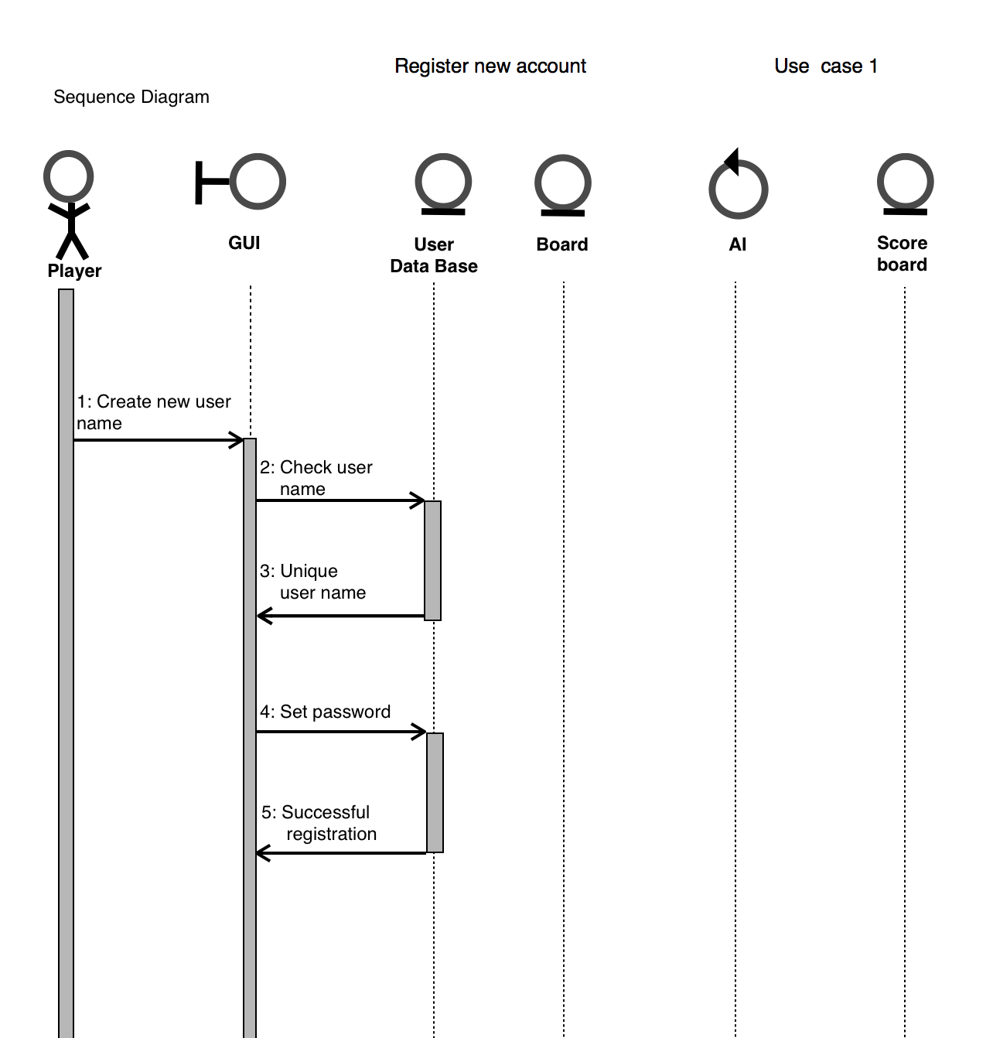

Use case 2(Log in)
General Description
The Log in use case enable a user/actor to enter his/her stored information in order to play the game as registered user and have the extra feature of tracking statistics available. The information entered includes the username and the password, in case that the password is forgotten then the user can exit this case to go to previous one and choose the option to reset password. Once the user logins successfully the other options are display in next window with another user case.
Sequence Diagram

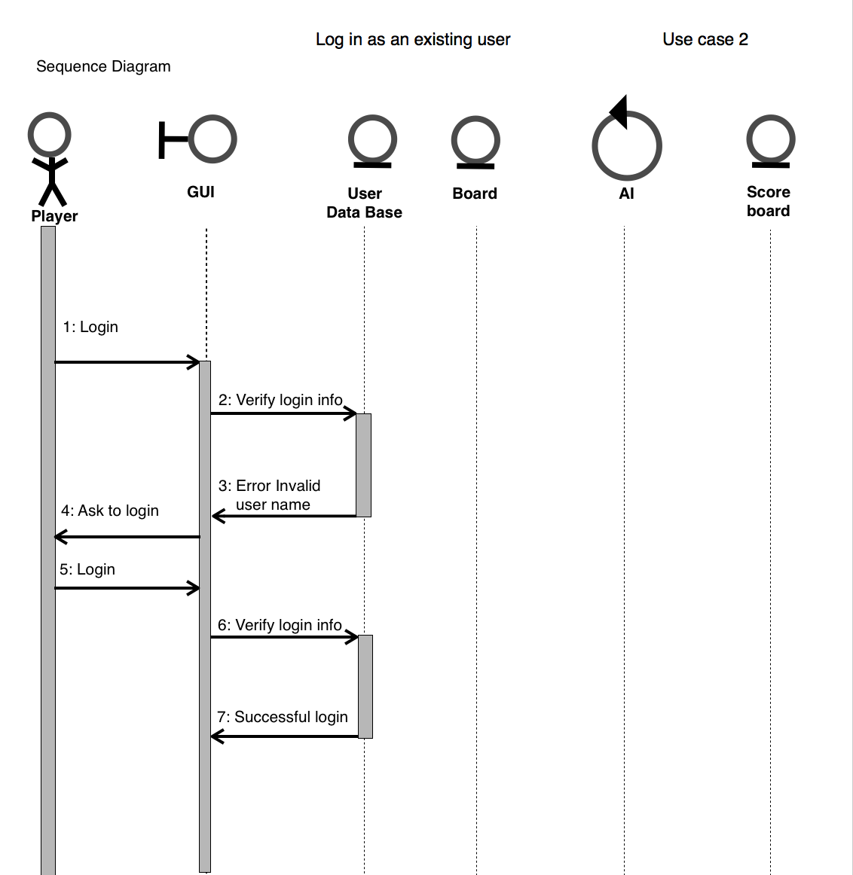

Use case 3(Play as Guest)
General Description
The Play as Guest use case enables the user/actor to choose to play without creating a new account or without logging in. No information is requested from the user and the user can choose to enter the new use case which is to start game in player vs. player mode and player vs. AI mode. This use case does not include the feature of tracking statistics.

Sequence Diagram

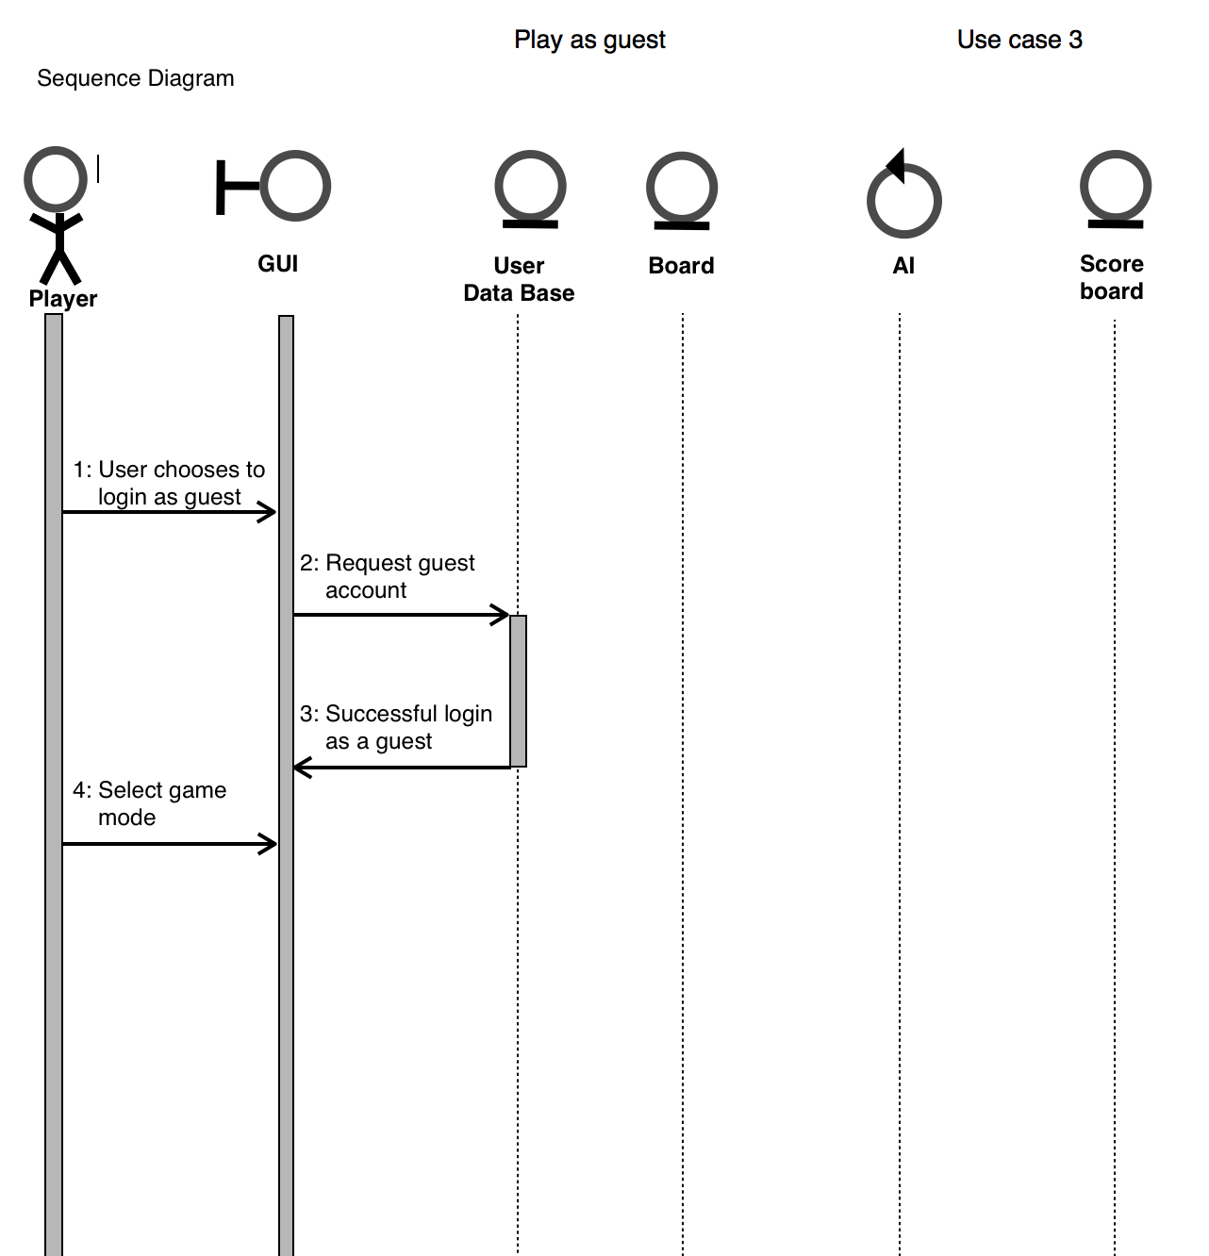

Use case 4(Reset Password)
General Description
The Reset Password use case enables the user to change his/her current password as long as the security question is answered correctly. The only information requested is the first name, last name, username and security answer. The database system updates the new password and the user is then taken to the main window of the program.
Sequence Diagram
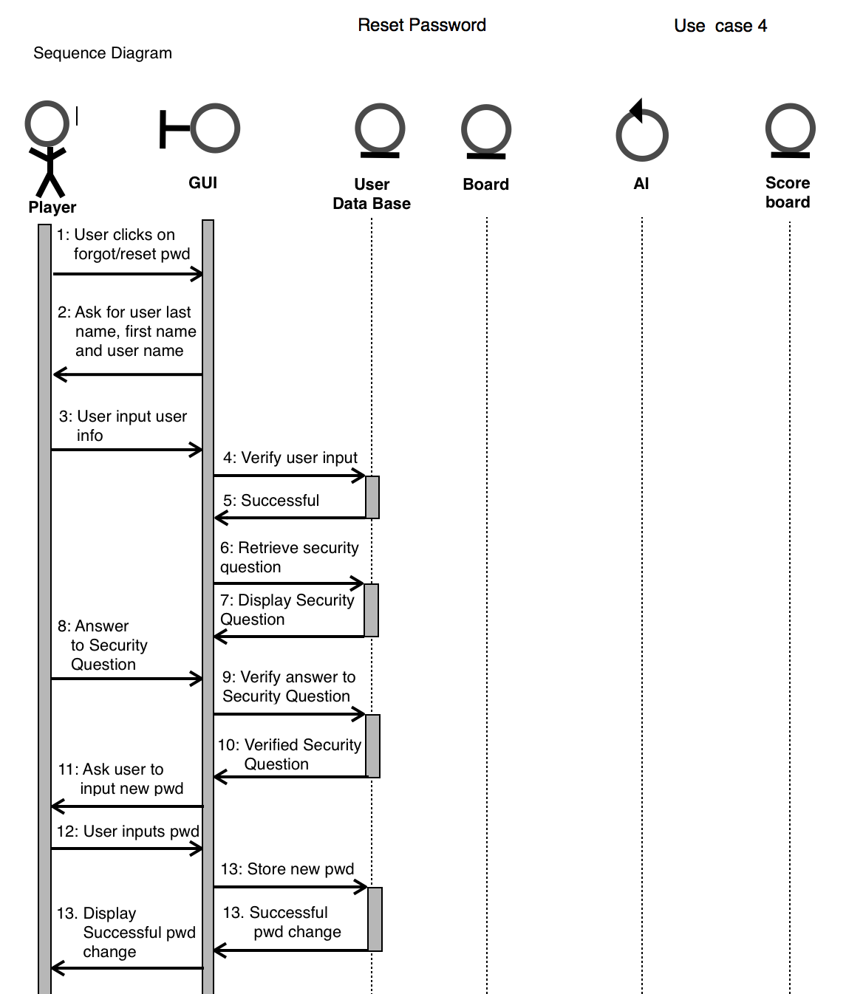

Use case 5(Display Player Statistics)
General Description
The Display Player Statistics enables the user to view his passed games history. This use case is only possible for the registered users and it does not retrieve information from the database if the user is a new registered user with not previously played games.
Sequence Diagram
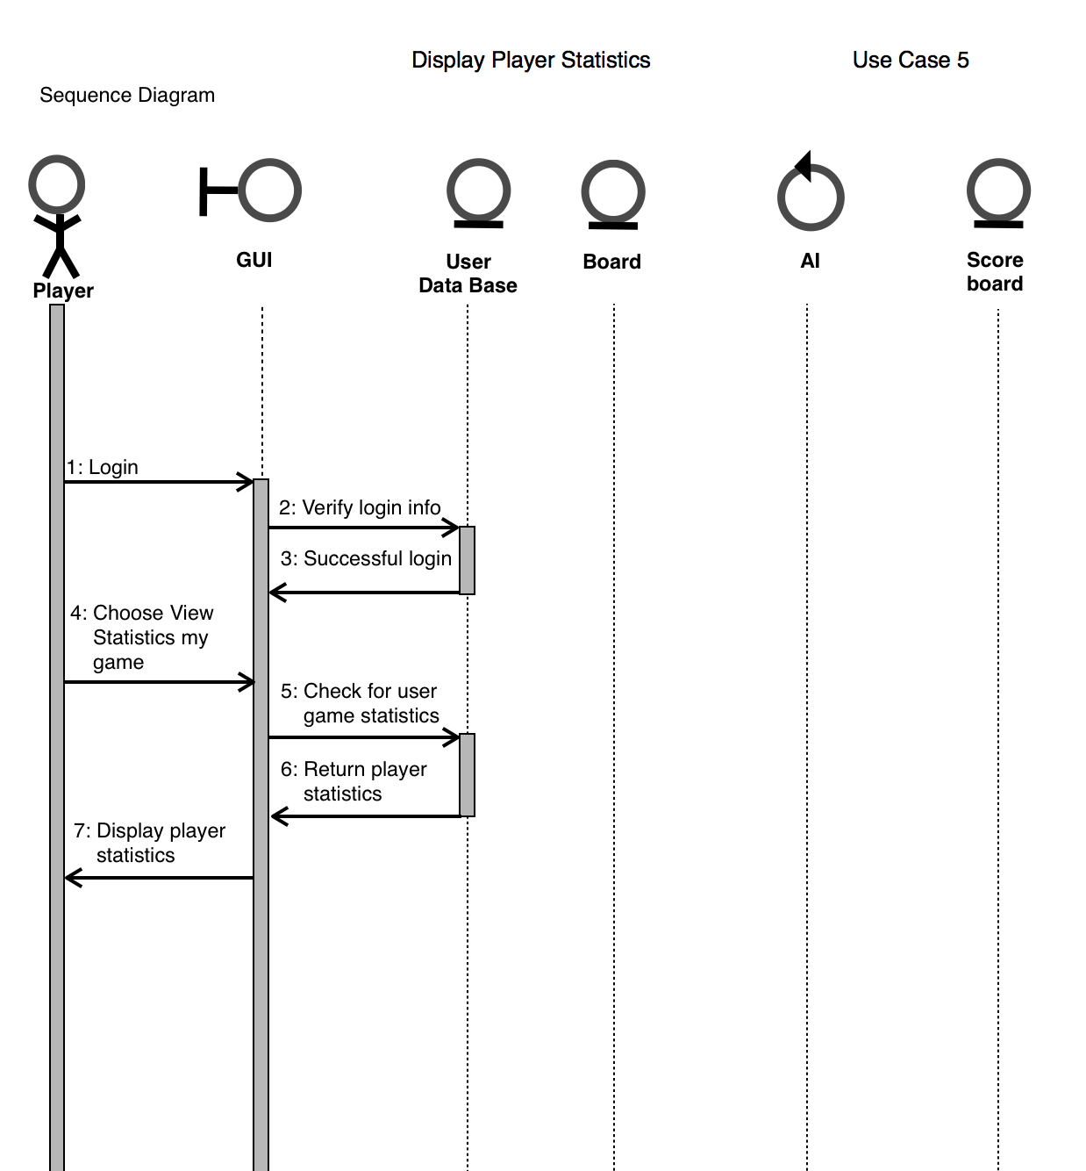

Use case 6(Player vs. Player)
General Description
The Player vs. Player use case enables the user to play against another player. This use case is available to registered user as well as to guest user. In this case the mode of play can only be chosen by the first player and any attempt from the seconds player to change mode will be handled with an error message.
Sequence Diagram
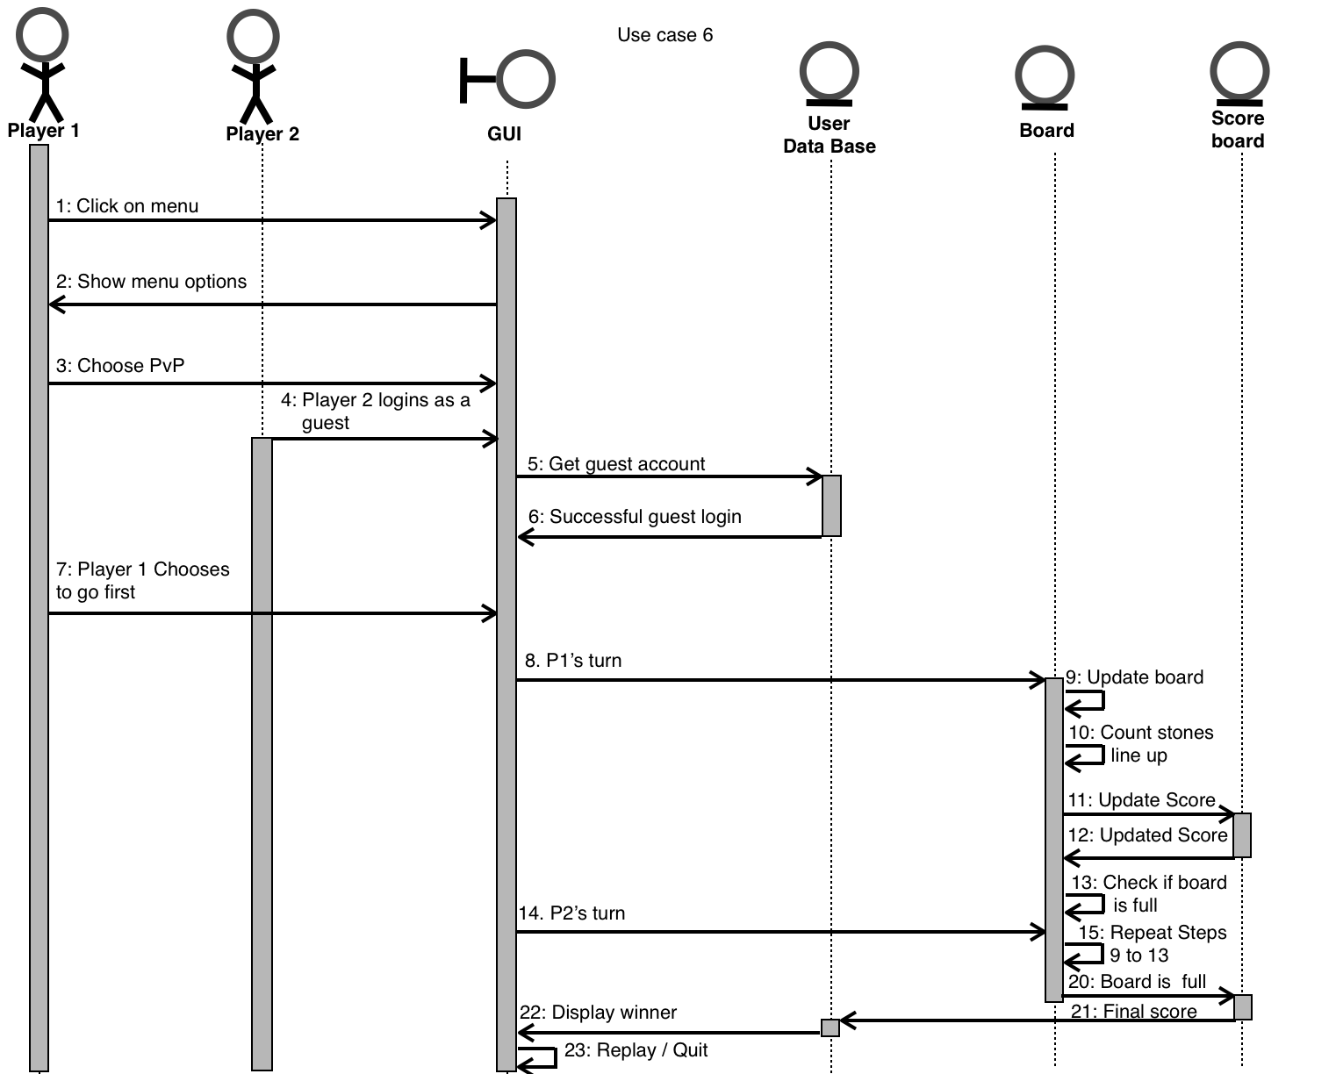

Use case 7(Player vs. AI)

General Description
The Player vs. AI use case enables the user to play against the computer.This use case is available to the registered user as well as to a guest user. In this use case the mode of play can only be chosen by the first player and any attempt from the second player to change mode will be handled with an error message.
Sequence Diagram
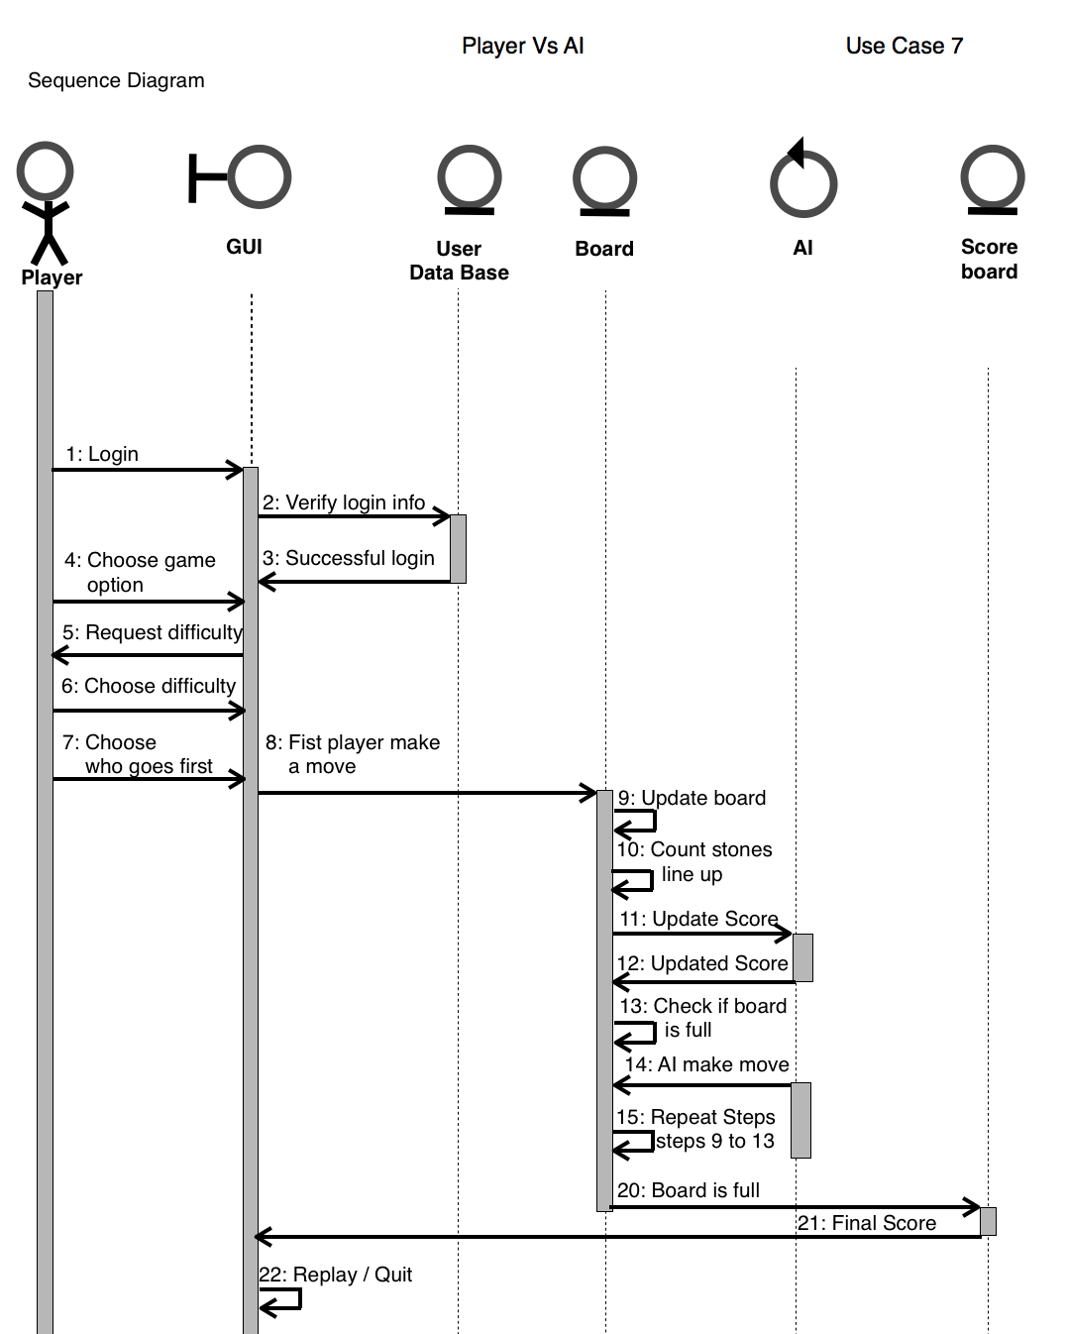

Use case 8(Difficulty Level)
General Description
The Difficulty Level use case enables the user/actor to choose a difficulty level from three given option: easy, medium, hard. This use case is only available to the player vs. AI mode and does not require the user to be a registered user.
Sequence Diagram
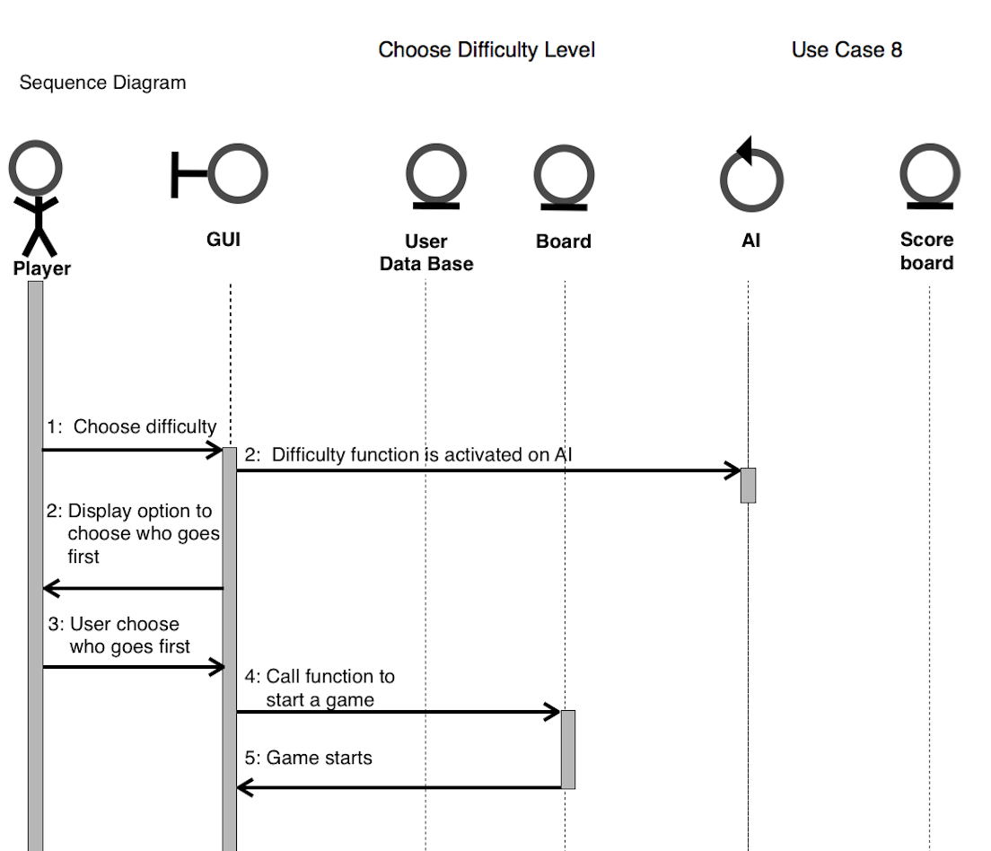

Use case 9(Select tile)
General Description
The Select Tile use case enables the user to choose between X which is blue and O which is red.
Sequence Diagram
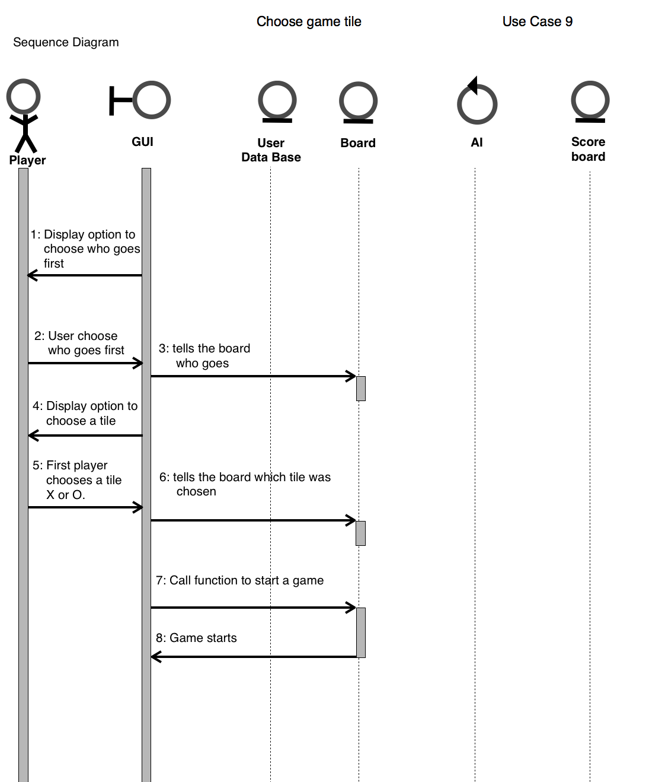

Use case 10(Select First Player)

General Description
The Select First Player use case enables the user to choose who will go first. It decides this based on the tile the player selected, it either lets tile X go first and tile O second or tile O first and tile X second.

Sequence Diagram
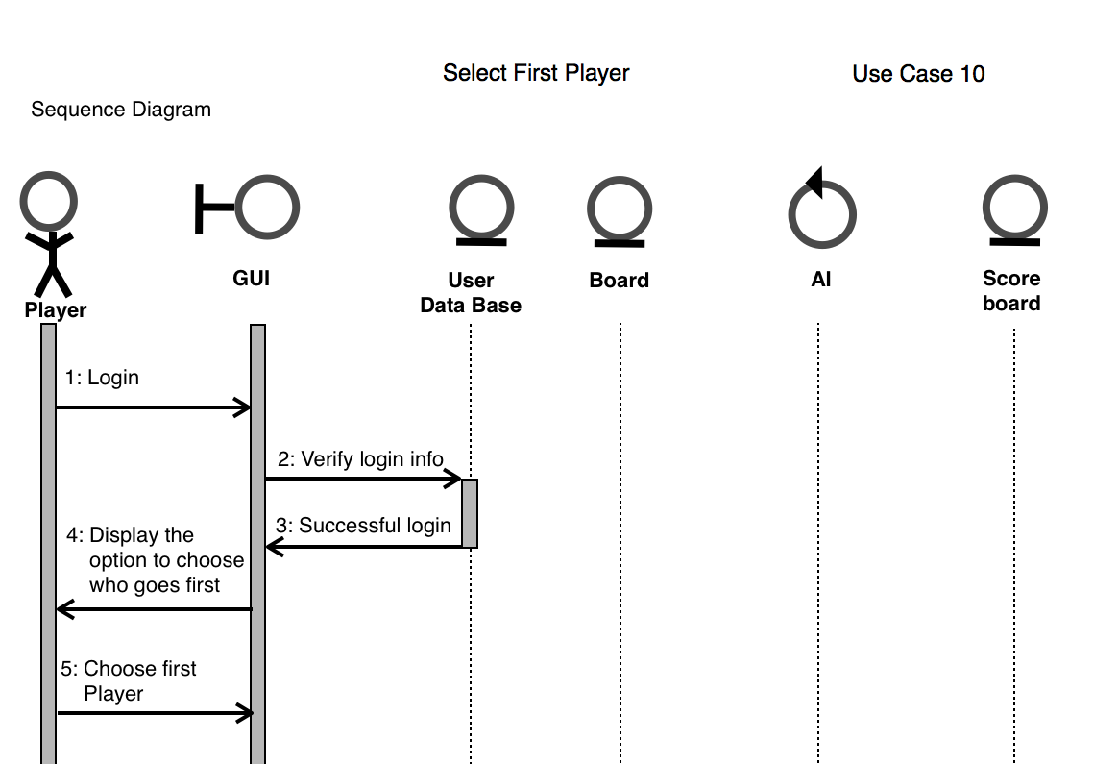

Use case 11(Exit)

General Description
The Exit use case enables the user/actor to close current window to go to previous one. This use case does not automatically exit the game but only allows to go one step back.
Sequence Diagram
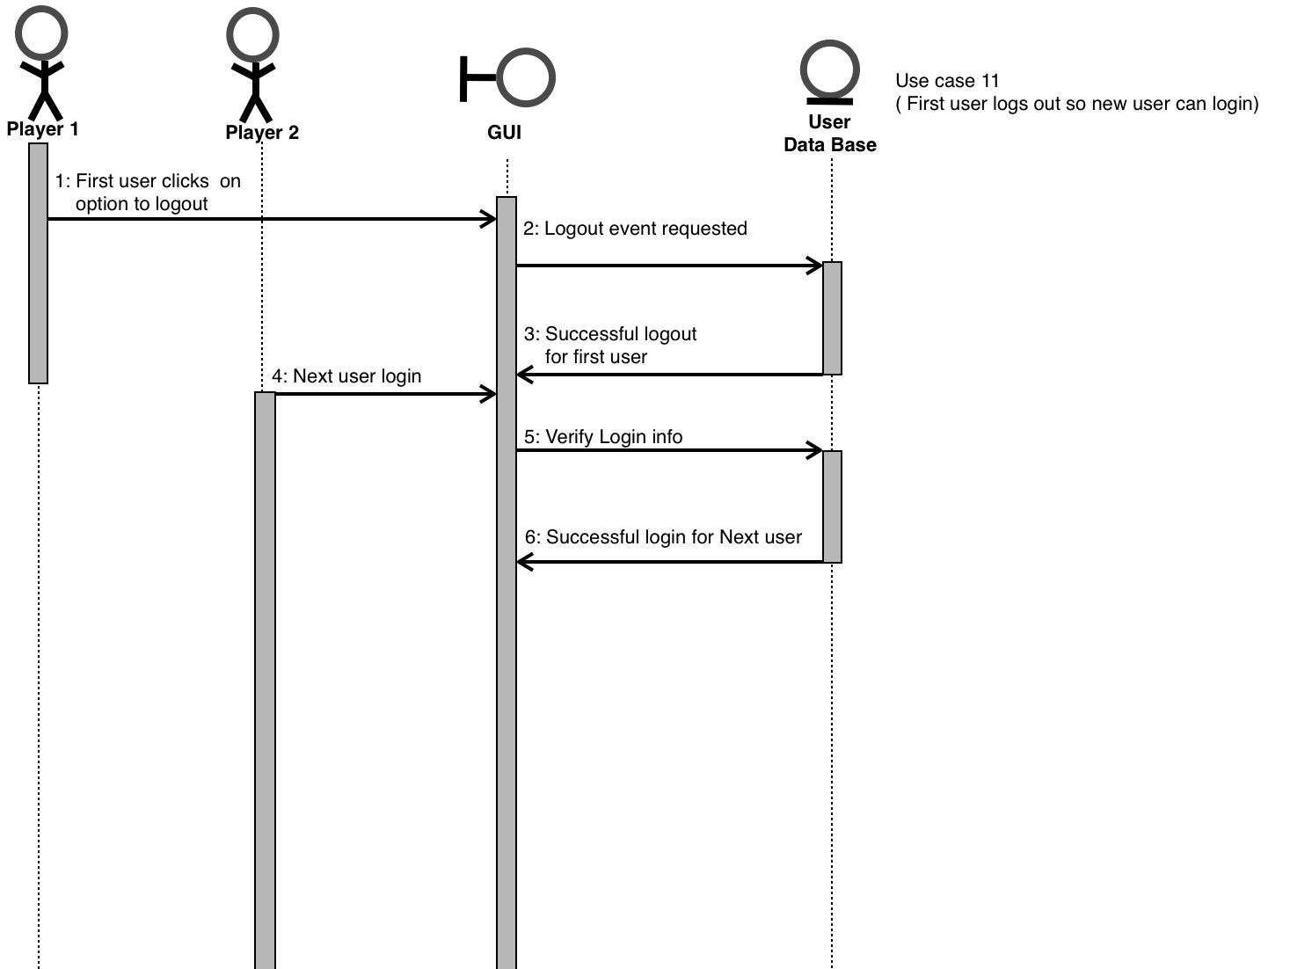

Exception Sequence Diagrams

Sequence Diagram
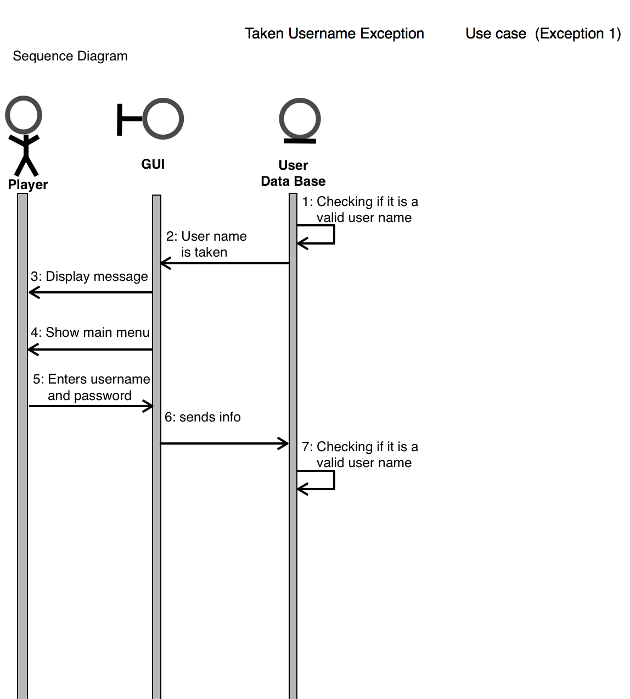

Use case 12(Taken Username)

General Description
The Taken User Name Exception use case enables the actor/user to choose another username in the case that entered one is an existent username in the database. The only information needed is the new username, password, and security question with answer.

Use case 13(Incorrect Log in information)
General Description
The incorrect log information is an exception use case that handles with the situation when a user tries to logging with incorrect username or password. The information needed for this case is username and password.
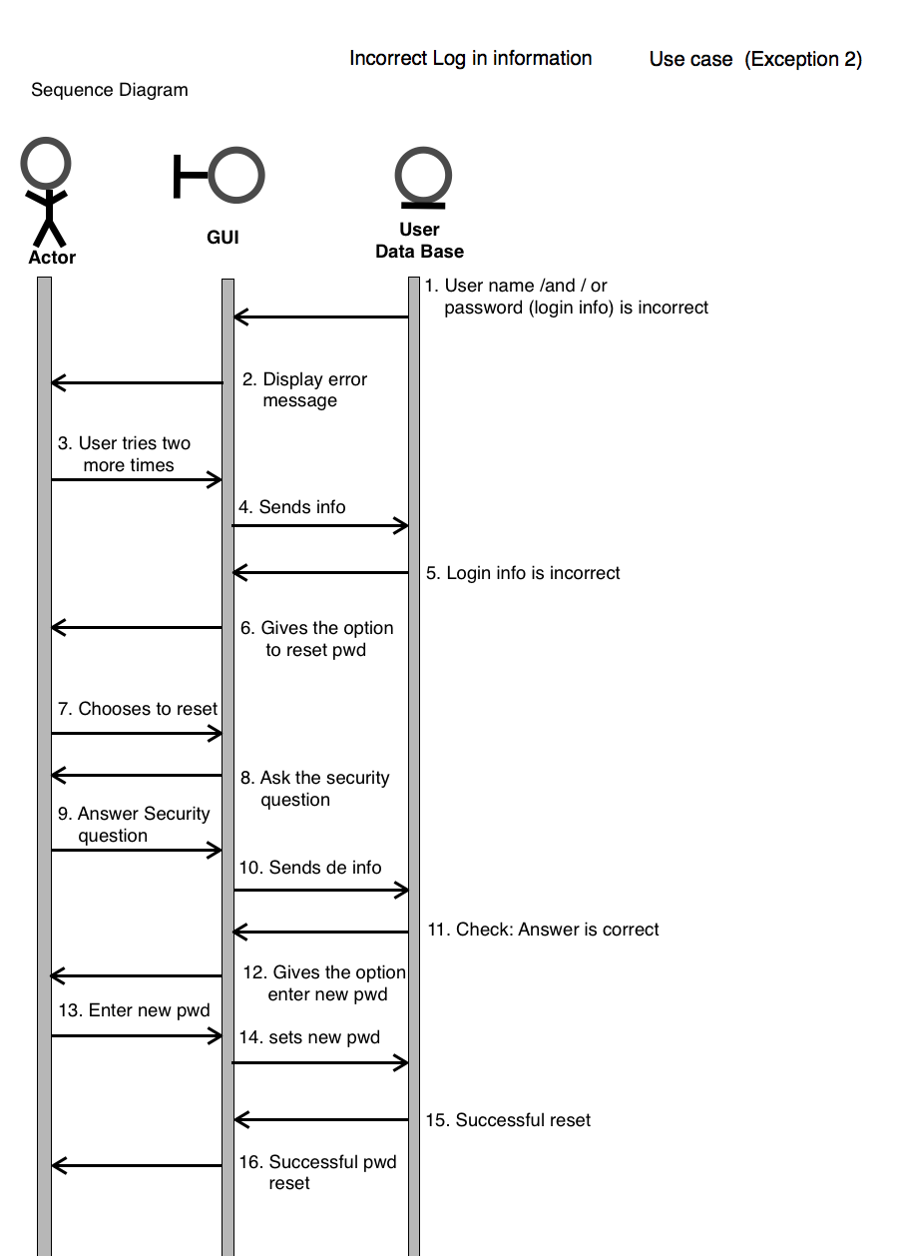
Sequence Diagram

Use case 14(Forgotten Username)
General Description
The forgotten username case handles the event when a user chooses the option forgot password on the main menu. The information needed is user lastname and security question. When the user inputs true value to these field the database will display the username.

Sequence Diagram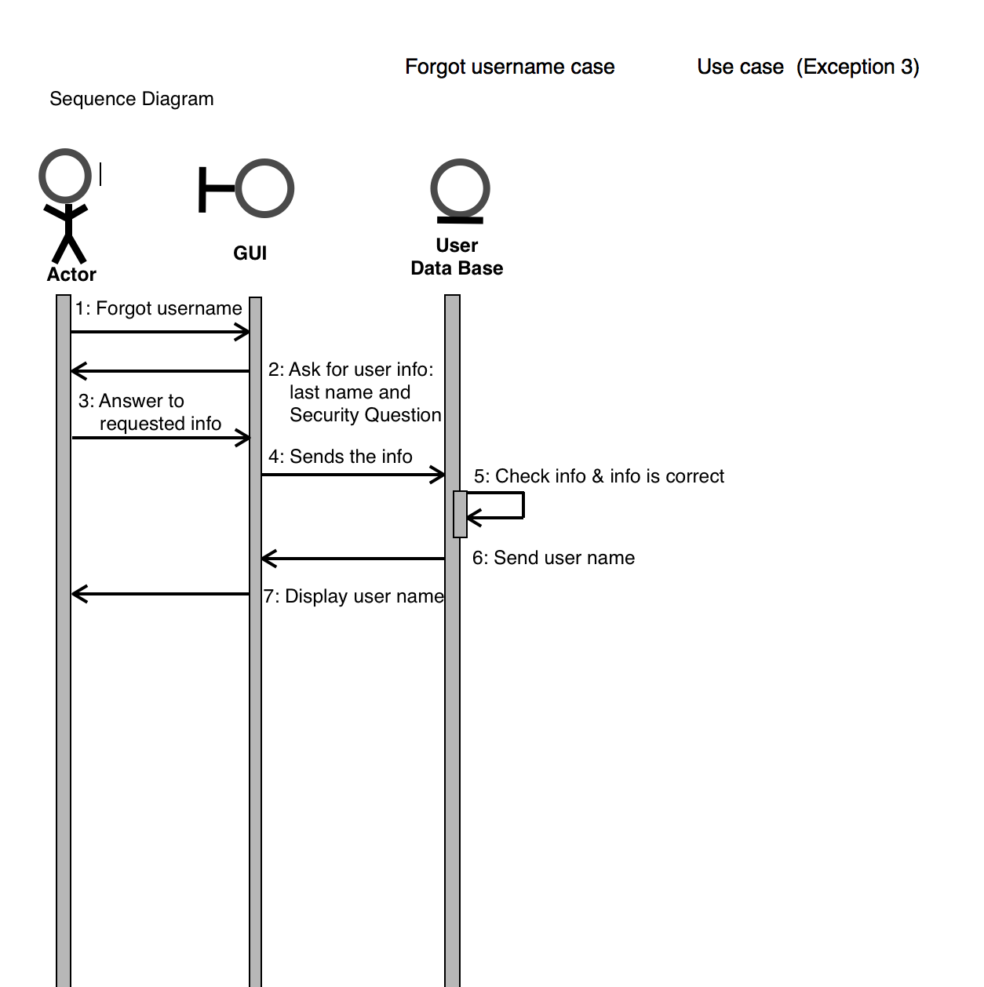

Use case 15 (Incorrect Answer to Security Question)

General Description
The Incorrect Answer to Security Question handles the event when a user answer not true value to the security question. The information needed is the answer to the security question. If user inputs a not true value to the security question a message incorrect answer will be displayed and the system will prompt the user for answer to security question.
Sequence Diagram
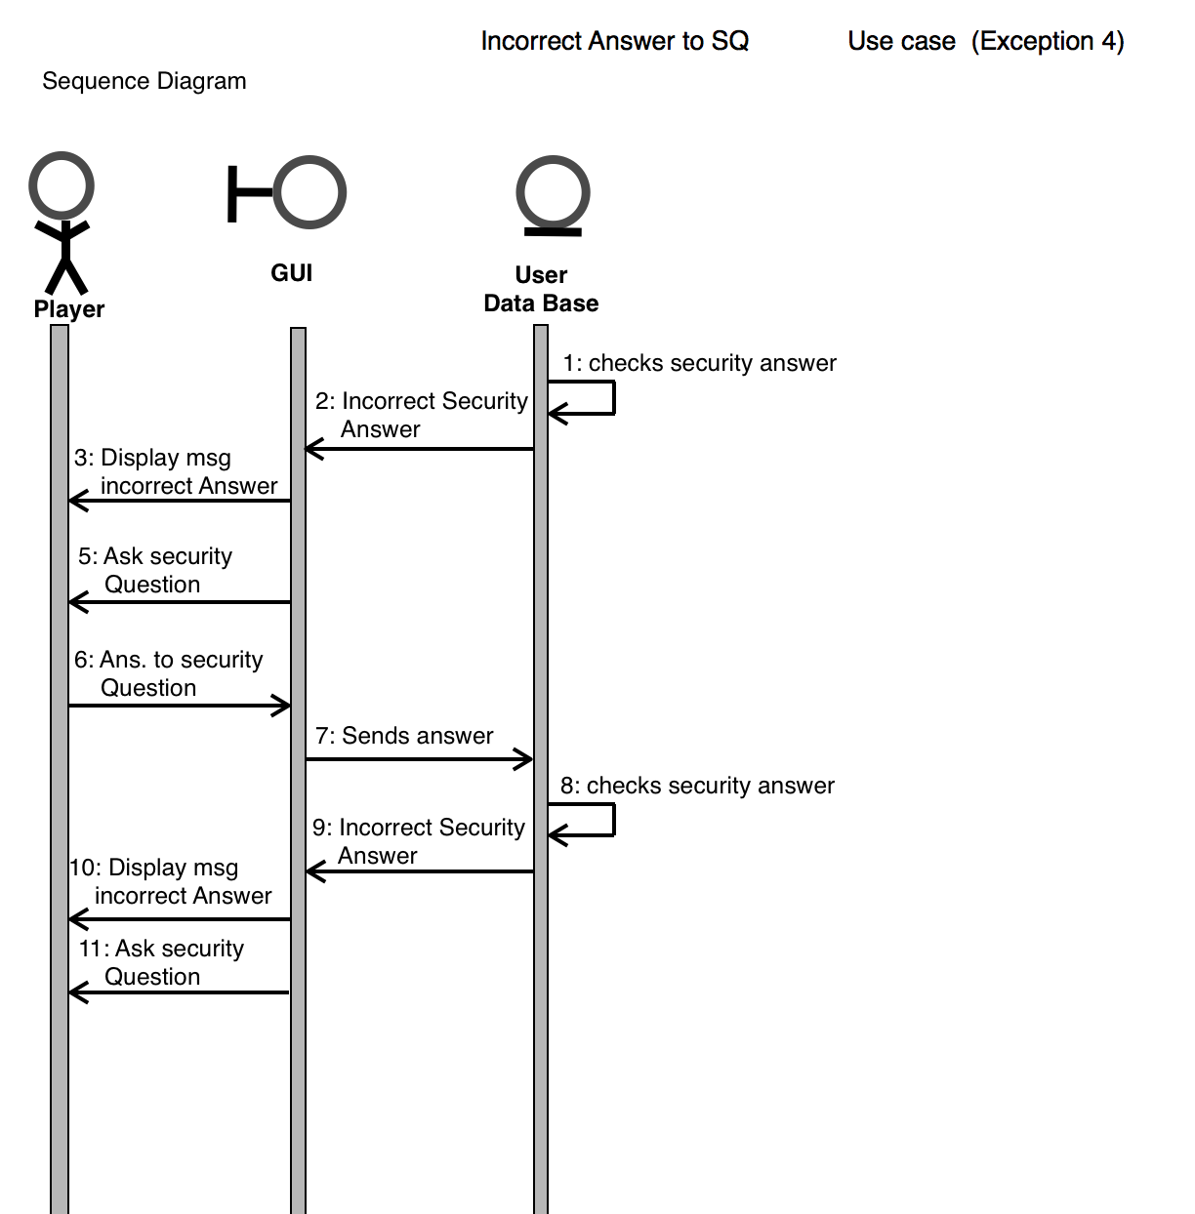

Use case 16 (Statistics for New User)
General Description
The statistics for new user handles the exception when a new user that never played tries to see the statistics of the game. The information need is username and password. When a new user tries to see statistics the system will display a message not statistics for new users.
Sequence Diagram
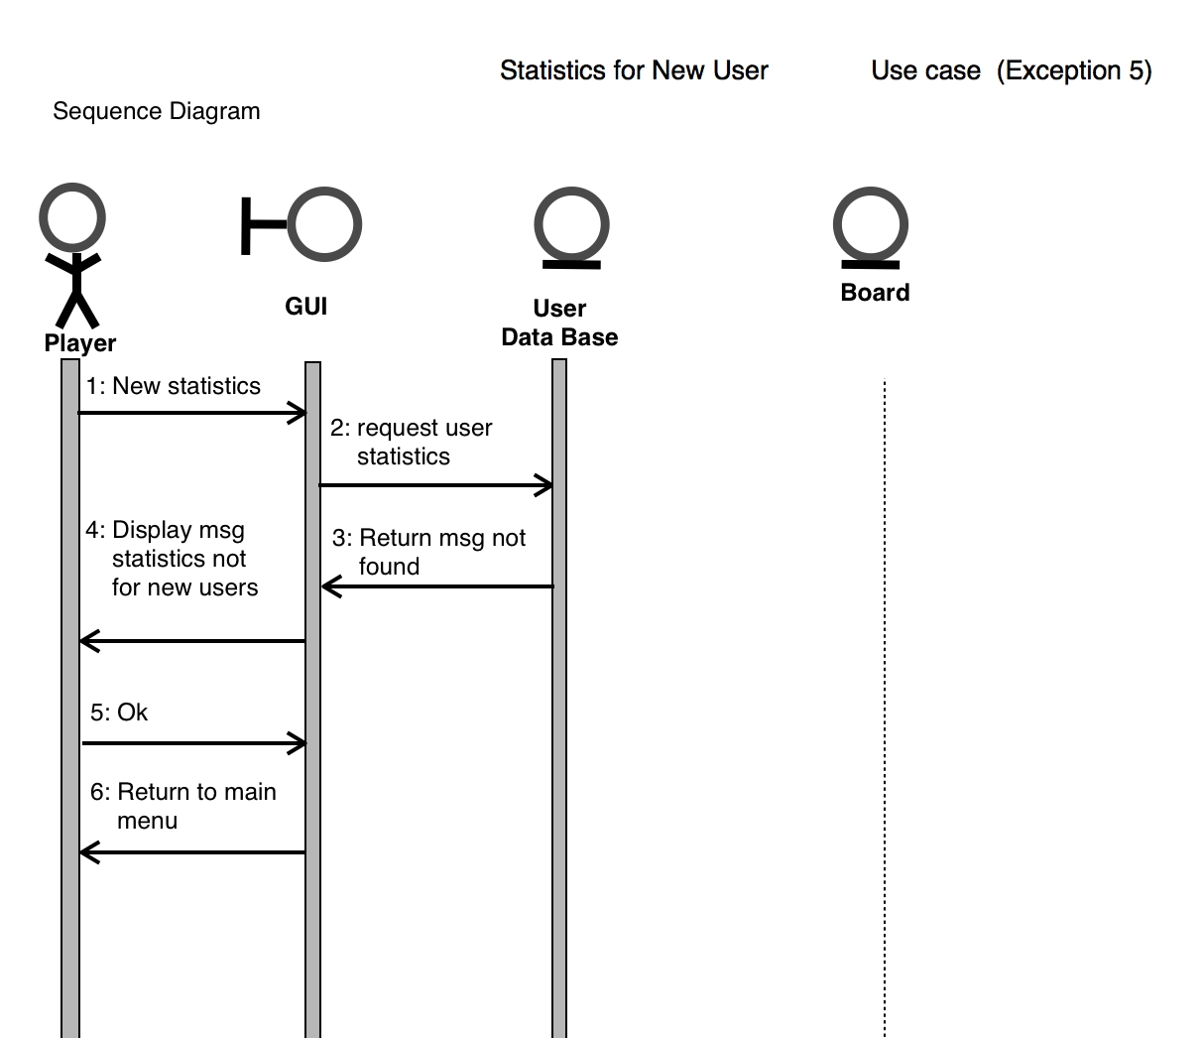

Use case 17 (Guest vs Guest)
General Description
The user chooses to login as a guest, then the Player vs Player option. The user is prompted to choose who would like to go first. The second player must then enter “Guest” into the username to continue to play with a Guest account. The game creates another Guest account for the second user and then generates the board to begin playing.
Sequence Diagram
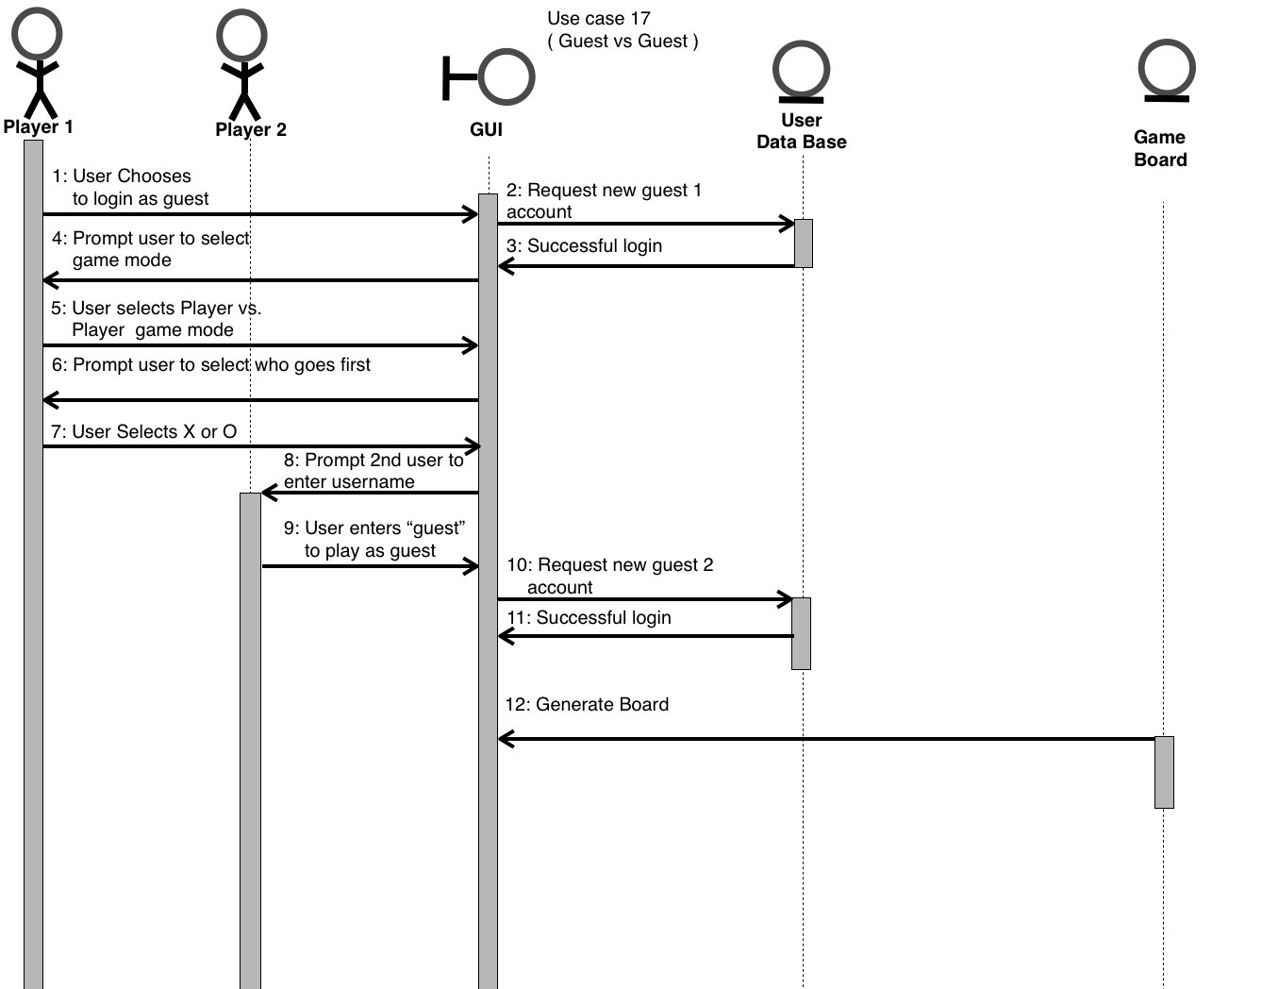

Use case 18 (Guest vs AI)
General Description
The user chooses to login as a Guest and is the prompted with a selection of game modes. They choose the Player vs AI mode, then they choose the level of difficulty they would like the AI to be. Then the user is prompted with who they would like to go first. The game board is generated and the first player makes a move.
Sequence Diagram
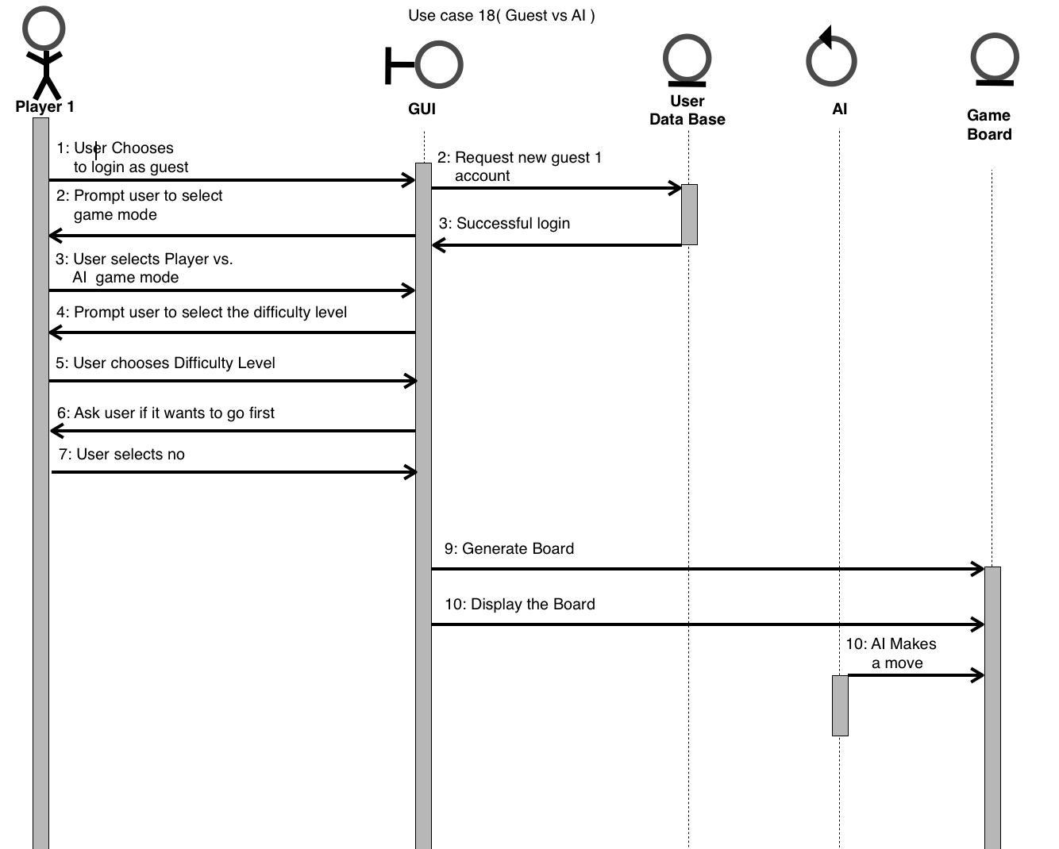

Use case 19 (Player vs Guest)
General Description
The user chooses to login as a registered user, then prompts them to choose a game mode. They select the Player Vs Player mode, then choose who would like to go first. The second user must enter “Guest” into the username field, then the game makes a Guest account for the player.
Sequence Diagram
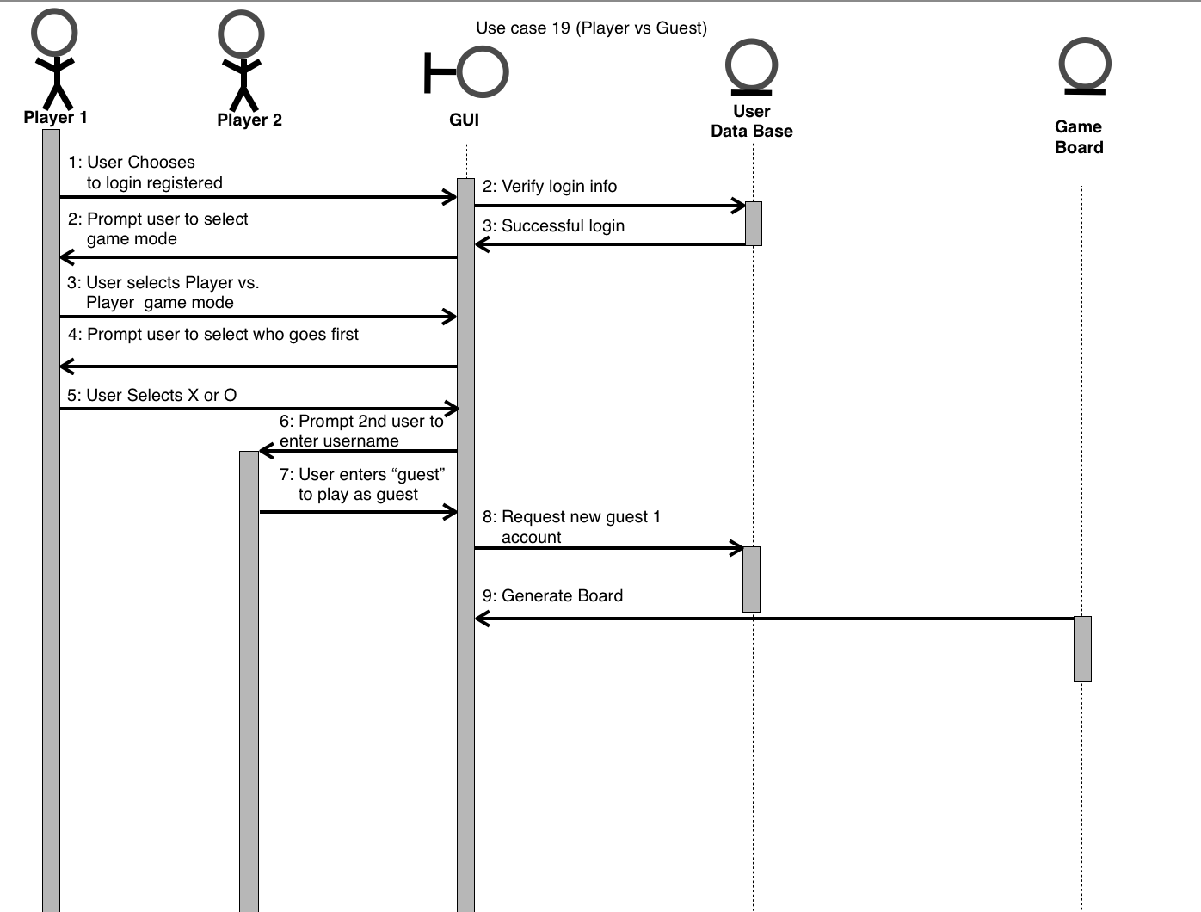

User Interface

